Module 1: Critical Thinking-Option #1: Categorical Attributes
Kimberly Statham
MIS510 – Data Mining and Visualization
Colorado State University – Global Campus
Dr. Eric Straw
March 27, 2020

Module 2: Critical Thinking-Option #1: Hot vs Cold Cereals
For this assignment a dataset on hot and cold cereals was explored and summarized. Histograms were generated for the quantitative columns in the dataset and a boxplot was produced depicting the difference in calories between hot and cold cereals.
Option #1: Hot vs Cold Cereals
From the histograms of the quantitative values, it was discovered that sodium and potassium had the biggest variance in values. Cups was an interesting histogram. It had a good amount of variance which most likely has an affect on most of the other quantitative variables. It would be interesting to know what all the quantitative values would be if all the cereals had a consistent volume, such as ¾ cup. The sugars histogram displayed seven cereals with zero sugars which was somewhat of a surprise. In viewing the records for these seven cereals, six of them also had zero vitamins. Maybe to mask the taste of vitamins, sugar is added to cereal.
The boxplot of the calories of hot and cold cereals is interesting. The boxplot for the hot cereal displays only one value for calories for all the hot cereals. Upon viewing the data and sorting on column type, it was discovered that the data only consisted of three hot cereal records and all three had 100 calories. The dataset did not contain enough hot cereal records to make the analysis adequate. The cold cereal had quite a few outliers. This may also be because the dataset is not very large. It would be an interesting study to plot calories with some of the nutrients to be known high in calories such as protein, sugars, and carbohydrates.
I discovered that when I found a plot interesting, I would then view the data in the tab from the View function and sort on various columns. When I get more comfortable with R programming, I should be able to do this same thing quickly using R functions which will be very beneficial when exploring large datasets. I chose to generate the histograms using both the hist() and ggplot functions(). About half the time I preferred the look of the hist() plot over the ggplot function. It will take some practice with ggplot geom_histogram map to figure out what the best binwidth or bins or breaks parameters should be to make the plot suitable.

Figure 1
Summary statistics using data.frame function.
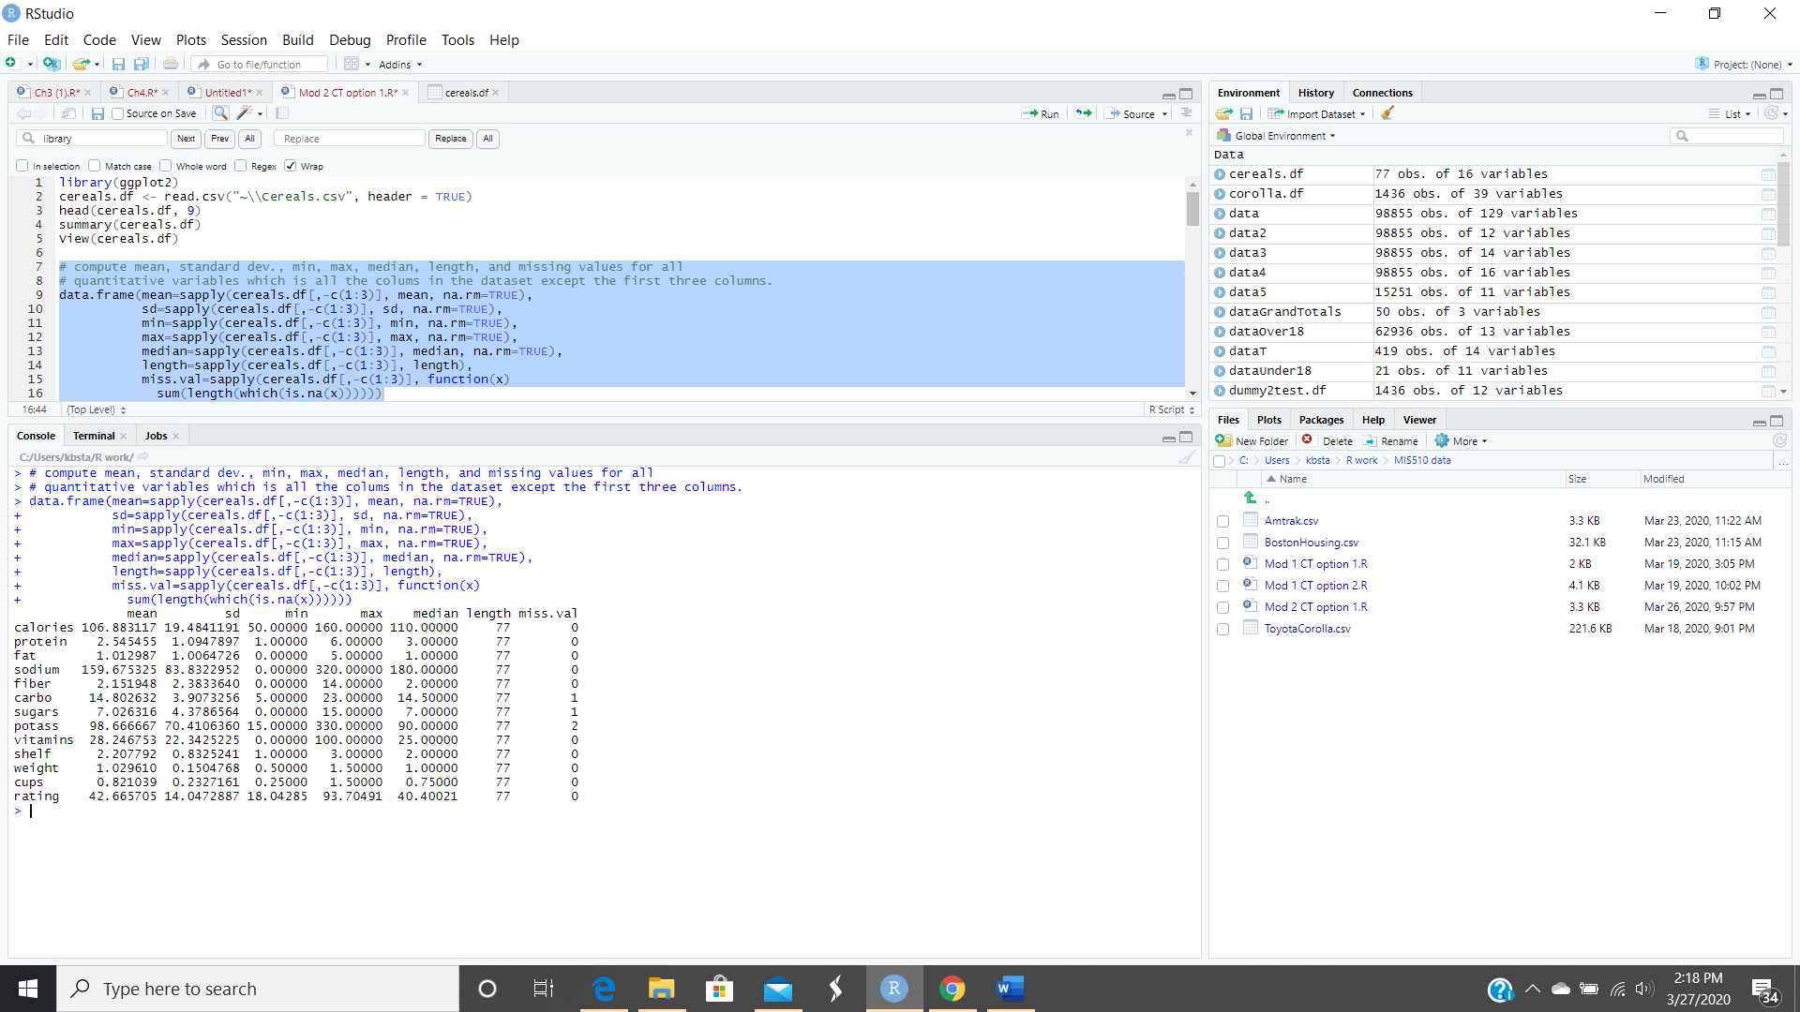

Figure 2
Histograms of the first eight quantitative columns.
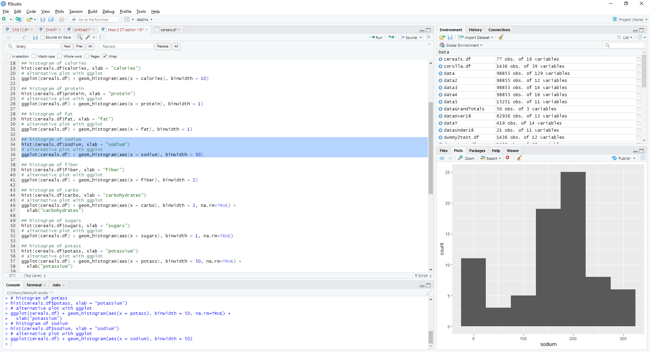

Figure 3
Histograms of the remaining five quantitative columns.
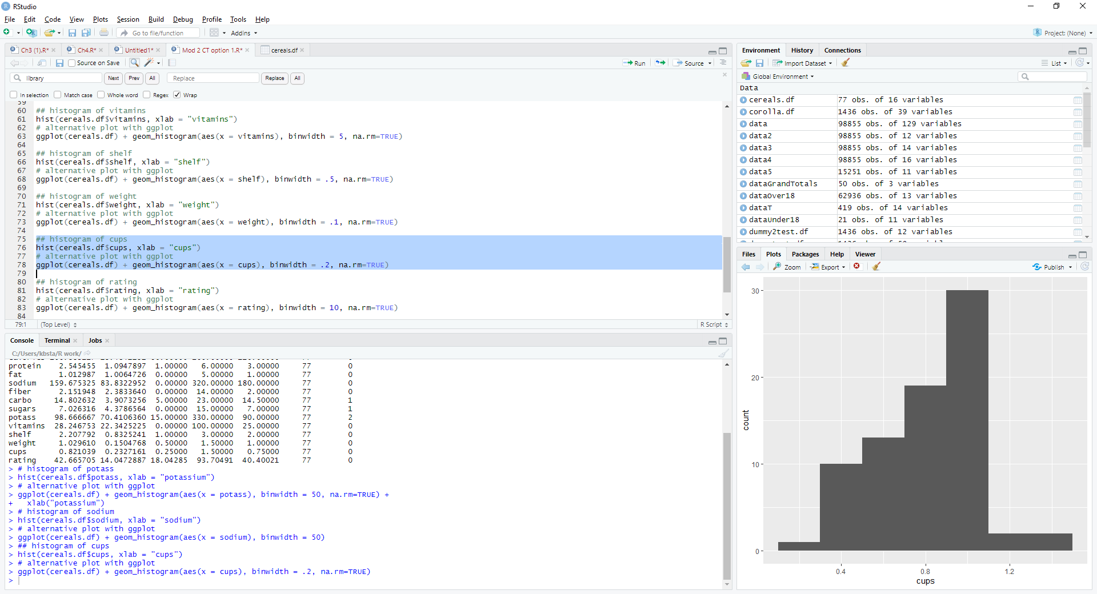

Figure 4
Boxplot of calories between Hot and Cold cereal
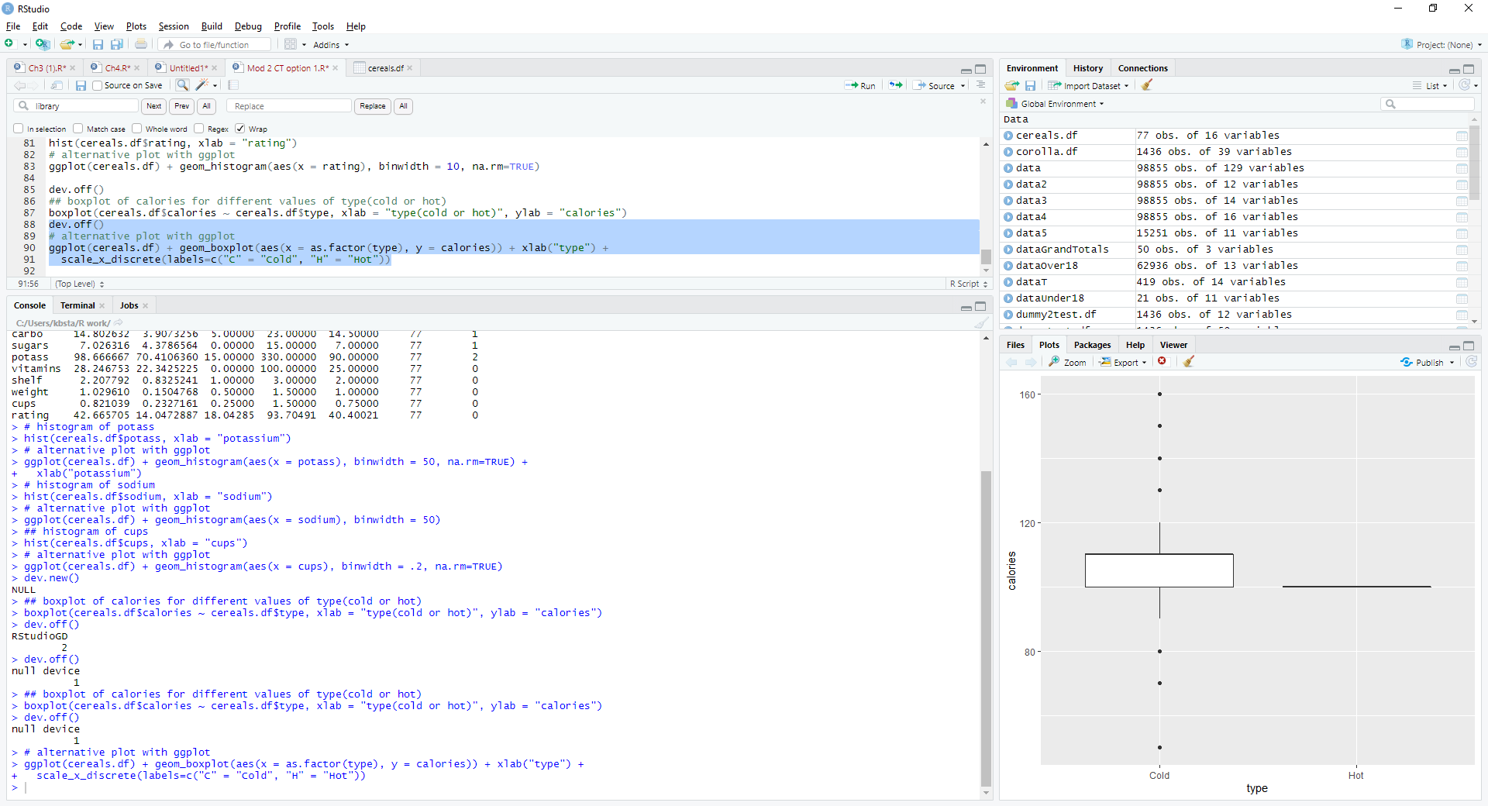

References
Shmueli, G., Bruce, P.C., Yahav, I., Pat (2020). Data Mining for Business Analytics. Chapter 3-4. Wileys.

